Job Description
Communications Manager

- Open Door

What we do
Open Door is the heart of Berkhamsted – a community and arts space where you can be active, creative and social, whatever your circumstances. We offer a wide range of activities, from workshops and exhibitions, to volunteering opportunities and other ways to make a difference. Or you can just come and have a cup of tea and a chat!

Helping to tackle social inequality and isolation is at the heart of what we do. We enable everyone to connect and contribute, for their own wellbeing and that of the wider community.

How we do it
Our core values guide the way we work and the decisions we make as a charity.

- We’re here for everyone We’re caring, welcoming and inclusive.
- We empower We provide opportunities to those who deliver and take part in our activities and services, and our staff, volunteers and supporters.
- We’re collaborative We unite the community, and work as a team with local people and organisations.

- The Communications Manager role

The Communications Manager role is a key role at Open Door and the individual is a full member of the Open Door Operational Team. The role is responsible for communication to a range of key stakeholders of the strategy and the activities/events delivered by Open Door.

Here is the leadership structure at Open Door:

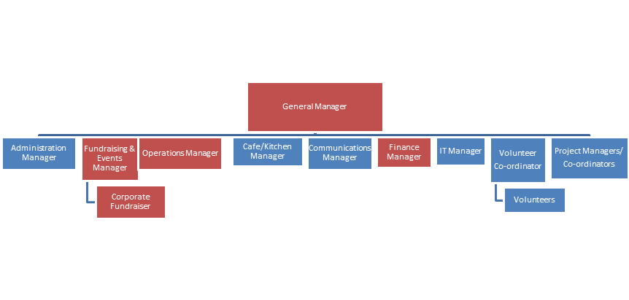
- Key Responsibilities

The Communications Manager will be responsible for implementation of an action plan to meet the communications goals of Open Door:

- Ensure everyone in Berkhamsted and the surrounding area knows about Open Door and the activities, opportunities and support that we offer within our community;
- Build Open Door’s brand as a community and creative hub; and,
- Support everyone who communicates on behalf of Open Door to do so effectively and consistently.

To achieve these communication goals, it is anticipated that you will:

- Develop messaging, plans and processes to ensure communications are co-ordinated, timely, consistent and within the brand that we have developed.
- Support the Open Door team to reach and engage people in the community who could benefit from our services, including the isolated and elderly.
- Manage and develop Open Door’s website, ensuring that all content is up-to-date, accessible and engaging.
- Manage Open Door’s social media channels (including Facebook, Instagram and Twitter) to increase the sense of community, promote our activities/services and raise funds.
- Write and produce monthly newsletters to engage supporters with our activities/services.
- Produce a monthly list of “What’s on at Open Door” and publish to promote the services that we provide into the community.
- Seek and respond to press/media opportunities to promote Open Door’s activities/services and raise our profile within the community.
- Build relationships with activity leaders and exhibitors to cross promote classes and events.
- Assist the Fundraising & Events Manager in promoting fundraising opportunities and thanking supporters for their contributions.
- Ensure that all Open Door communications are clear, accessible and follow our brand guidelines, including supporting others who are communicating on behalf of Open Door.
- Measure the impact of communication campaigns to see that they are both effective and ensure that the tone, content and approach is appropriate.

- Key Relationships

The role reports to the Open Door General Manager. Key internal relationships will be with other members of the Open Door Operational Team (Fundraising & Events Manager, Operations Manager, Administration Manager, Café/Kitchen Manager, Finance Manager, IT Manager and Volunteer Co-ordinator), Project Managers/Co-ordinators and Volunteers. Key external relationships will include a broad range of media (printed and on-line), other charities, pressure groups, funding organisations, local authorities etc.

- Is this you?

We are looking for a creative, passionate and caring Communications Manager with the commitment and time to get stuck in and take Open Door forwards. We have a great story and we really need to ensure that it is told properly in our community.

We think this role needs:

- Strong written and verbal communication skills;
- Experience of developing and implementing communication plans;
- Experience of building effective relationships with internal and external stakeholders;
- Experience of managing social media channels and of developing and championing agreed brand guidelines; and,
- Ability to work effectively within a team and independently.

- Working Hours

This is a voluntary role and working hours are very flexible, but we expect it to require around 15 hours per week. We are flexible in terms of location of the role with time spent at home and/or at Open Door.

- To Apply...............

Please submit an application, with a covering email and CV, to iain.manson@opendoorberkhamsted.co.uk. If you have any questions, please email or call Iain on +44 7917327384. Applications will close on Thursday 24 March 2022 at 5.00pm. We intend to hold interviews for the role during the week of Monday 28 March 2022.

Drafted/Updated: Friday 04 March 2022

