Job Description
Administration Manager

- Open Door

What we do
Open Door is the heart of Berkhamsted – a community and arts space where you can be active, creative and social, whatever your circumstances. We offer a wide range of activities, from workshops and exhibitions, to volunteering opportunities and other ways to make a difference. Or you can just come and have a cup of tea and a chat!

Helping to tackle social inequality and isolation is at the heart of what we do. We enable everyone to connect and contribute, for their own wellbeing and that of the wider community.

How we do it
Our core values guide the way we work and the decisions we make as a charity.

- We’re here for everyone We’re caring, welcoming and inclusive.
- We empower We provide opportunities to those who deliver and take part in our activities and services, and our staff, volunteers and supporters.
- We’re collaborative We unite the community, and work as a team with local people and organisations.

- The Administration Manager role

The Administration Manager role is a key role at Open Door and the individual is a full member of the Open Door Operational Team. The role is responsible for providing key administrative support to the operations of Open Door, particularly around the booking of events, activities and exhibitions.

Here is the leadership structure at Open Door:

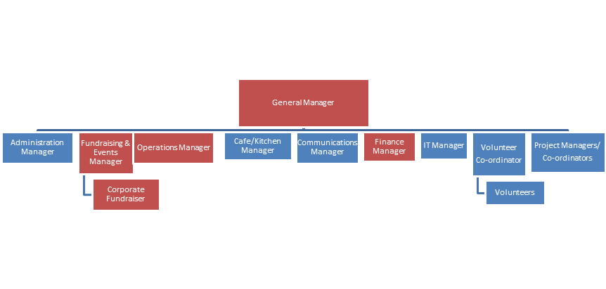
- Key Responsibilities

The Administration Manager will be responsible across the key supporting administrative processes for Open Door:

- Workshop and event bookings:
  - Agreeing a schedule of workshops/events with the General Manager/Operations Manager;
  - Agreeing with workshop/course providers to confirm information about the course and images for booking and promotion;
  - Creating booking forms for each course/workshop;
  - Managing the automated booking system covering courses and workshops (Bookwhen);
  - Liaising with course participants and setting up relevant sessions;
- Venue hire:
  - Sending out venue hire forms and T&Cs;
  - Updating venue hire spreadsheet/booking system with details;
  - Correspondence with hirers to answer questions, confirm bookings etc.
- Exhibition admin:
  - Working with the General Manager to confirm a schedule of exhibitions;
  - Confirming information / images to use to promote exhibitions;
  - Writing / editing call for artists for open submissions;
  - Briefing volunteers re exhibitions support.
- Other Administration:
  - Members, Trustees and Management Committee meetings - organising and minute taking;
  - Operational Team meetings - organising and minute taking;
  - Planning and schedules - keeping online schedule of activities up to date;
  - Looking after the info@opendoor inbox - answering enquiries, forwarding on relevant enquiries to the team;
  - Filing; and,
  - Office supplies

- Key Relationships

The role reports to the Open Door General Manager. Key internal relationships will be with other members of the Open Door Operational Team (Fundraising & Events Manager, Operations Manager, Communications Manager, Café/Kitchen Manager, Finance Manager, IT Manager and Volunteer Co-ordinator), Project Managers/Co-ordinators and Volunteers. Key external relationships will be the people running and considering running events, classes and exhibitions at Open Door.

- Is this you?

We are looking for a creative, passionate and caring Administration Manager with the commitment and time to really get stuck in and take Open Door forwards. We think this role needs:

- Strong administrative and organisational skills and the ability to multitask, with attention to detail;
- Experience of Microsoft Office, including Excel, Word and Outlook;
- Strong written and verbal communication skills;
- People management experience and skills;
- Experience of building effective relationships with internal and external stakeholders; and,
- Ability to work effectively within a team and independently.

- Working Hours

This is a voluntary role and working hours are very flexible, but we expect it to require around 15 hours per week. We are flexible in terms of location of the role with time spent at home or at Open Door.

- To Apply...............

Please submit an application, with a covering email and CV, to iain.manson@opendoorberkhamsted.co.uk. If you have any questions, please email or call Iain on +44 7917327384. Applications will close on Thursday 24 March 2022 at 5.00pm. We intend to hold interviews for the role during the week of Monday 28 March 2022.

Drafted/Updated: Friday 04 March 2022

