Do you know someone who is lonely, clinically vulnerable or self-isolating?

Or anyone who might benefit from some gentle guided movement & social interaction online?

Come & join our small friendly group led by Hil
Chair yoga class
Every Thursday 10.30-11.30am on Zoom
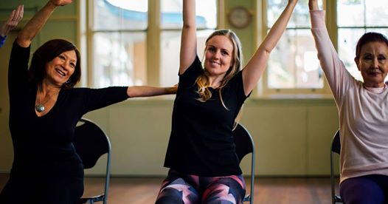
An hour of functional mindful movement & breathwork from the comfort of your own home (do it in your pyjamas if you want!), designed to improve joint mobility, strength, balance, coordination, confidence & mood. Often with a social cuppa & chat online afterwards.
No flexibility or previous experience required. Donations up to £8, depending on your financial circumstances.

Please get in touch with Hil to find out more on 0796325257 or hgwarrell@hotmail.co.uk

